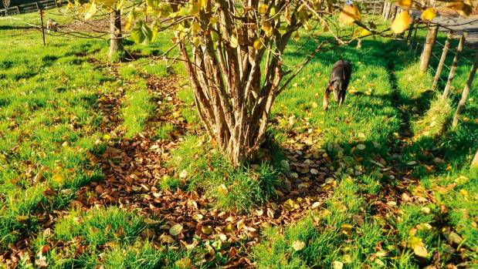  2018 NZ Truffle COnference & AGM  18th – 19th August 2018  “NZ Truffles – The Future”  The 2018 NZTA Conference & AGM is be held in Tauranga, the heart of the largest grouping of NZTA members and growers in the country.  Hear from speakers in an array of fields, from the future of truffle production in NZ, or rejuvenating your orchard, to the role of the hazelnut. We’ll also hear about the importance of food safety aspects and the 2018 season through the eyes of an expert dog handler.  We’ll be updating you on our research projects, showcasing fresh truffle and visiting a local orchard where you’ll be given the chance to touch feel and compare an array of truffles.  Join us for a fun-filled, inspirational weekend, with plenty of chances to learn from and connect with fellow truffle lovers. | What does the future hold? Listen to the experts!  ────  Research Update Our first project in 15 years  ────  Field trip to local truffiere  ────  Sample fresh melanosporum & Bianchetto  ────  Register Now  18th – 19th August 2018  Tauranga  Saturday 18th August at  Trinity Wharf  Sunday 19th August  On location

